
First Sunday in Lent

CHRIST LUTHERAN CHURCH | Lodi, California
February 22, 2026

WELCOME TO WORSHIP
Welcome to Christ Lutheran Church. We pray that your soul will be strengthened by the good news about God’s grace, love, and forgiveness given to us. If you would like to learn more about our church, please speak with our pastor or one of our members after the service.
- Bathrooms are located in the fellowship hall. A changing table is located in the women’s bathroom.
WORSHIP THEME
Jesus succeeds where we fail. As our substitute, Jesus has faced every trial and temptation that humanity must face, and has conquered them all. Where Adam fell into sin, Christ rose above the allure and accusation of the devil. Where Adam and Eve died, Christ rose to new life. In Him, we will conquer and rise.
Matins
Matins was the service that marked the beginning of a new day for the monastic orders. Morning is a natural and necessary time for prayer, praise, and worship. As we begin not just a new day, but a new week, we glorify God and ask for his blessing.
HYMN All Mankind Fell in Adam’s Fall| CW 556
M: In the name of the Father, and of the Son, and of the Holy Spirit.
C: Amen.
M: O Lord, open my lips
C: And my mouth shall declare your praise.
M: Hasten to save me, O God.
C: O Lord, come quickly to help me.
CONFESSION
M: Beloved in the Lord: let us draw near with a true heart and confess our sins to God our Father, asking him in the name of our Lord Jesus Christ to grant us forgiveness.
C: Holy and merciful Father, I confess that I am by nature sinful, and that I have disobeyed you in my thoughts, words, and actions. I have done what is evil and failed to do what is good. For this I deserve your punishment both now and in eternity. But I am truly sorry for my sins, and trusting in my Savior Jesus Christ, I pray: Lord, have mercy on me, a sinner.

absolution
M: God, our heavenly Father, has been merciful to us and has given his only Son to be the atoning sacrifice for our sins. Therefore, as a called servant of Christ and by his authority, I forgive you all your sins in the name of the Father and of the Son ✙ and of the Holy Spirit.
C: Amen
M: The Spirit of the Lord fills the world. Let us worship him.
O COME LET US SING TO THE LORD
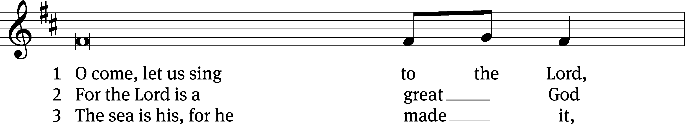
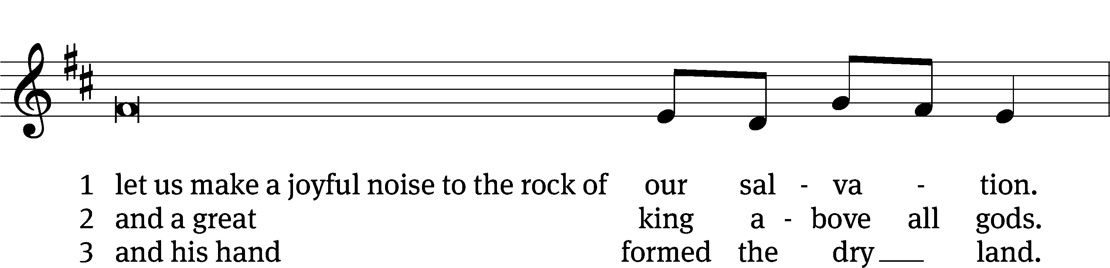

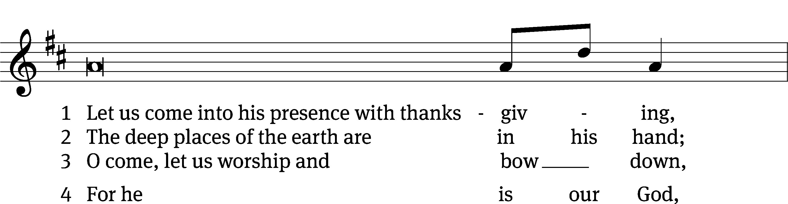
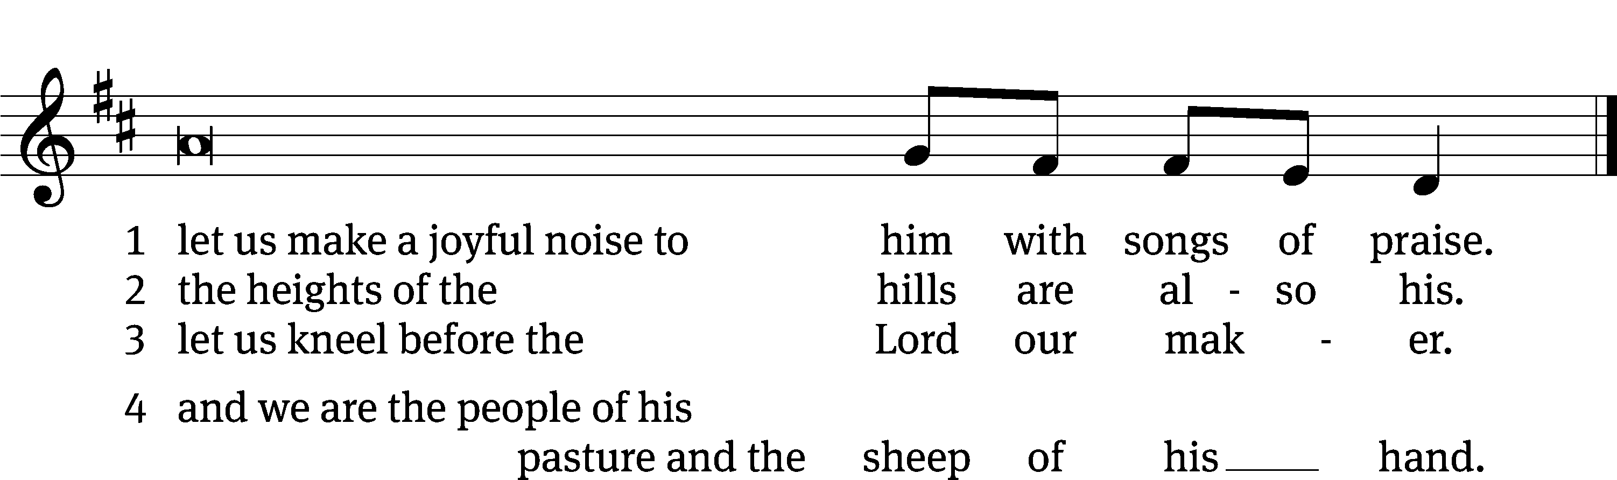
PRAYER OF THE DAY
M: The Lord be with you.
C: And also with you.
M: Let us pray.
Mighty God and Father, our Lord Jesus walked into the wilderness to face the devil’s temptations, but he did not succumb to Satan’s lies or falter in his resolve to save the world from the prison of hell. Bolster our faith by his mighty victory that we may battle against the forces of evil with courage and confidence; through your Son, Jesus Christ our Lord, who lives and reigns with you and the Holy Spirit, one God, now and forever.
C: Amen
FIRST LESSON Genesis 3:1–15
The fall into sin.

Now the serpent was more crafty than any of the wild animals the Lord God had made. He said to the woman, “Did God really say, ‘You must not eat from any tree in the garden’?”
The woman said to the serpent, “We may eat fruit from the trees in the garden, but God did say, ‘You must not eat fruit from the tree that is in the middle of the garden, and you must not touch it, or you will die.’”
“You will not certainly die,” the serpent said to the woman. “For God knows that when you eat from it your eyes will be opened, and you will be like God, knowing good and evil.”
When the woman saw that the fruit of the tree was good for food and pleasing to the eye, and also desirable for gaining wisdom, she took some and ate it. She also gave some to her husband, who was with her, and he ate it. Then the eyes of both of them were opened, and they realized they were naked; so they sewed fig leaves together and made coverings for themselves.
Then the man and his wife heard the sound of the Lord God as he was walking in the garden in the cool of the day, and they hid from the Lord God among the trees of the garden. But the Lord God called to the man, “Where are you?”
He answered, “I heard you in the garden, and I was afraid because I was naked; so I hid.”
And he said, “Who told you that you were naked? Have you eaten from the tree that I commanded you not to eat from?”
The man said, “The woman you put here with me—she gave me some fruit from the tree, and I ate it.”
Then the Lord God said to the woman, “What is this you have done?”
The woman said, “The serpent deceived me, and I ate.”
So the Lord God said to the serpent, “Because you have done this,
“Cursed are you above all livestock
and all wild animals!
You will crawl on your belly
and you will eat dust
all the days of your life.
And I will put enmity
between you and the woman,
and between your offspring and hers;
he will crush your head,
and you will strike his heel.”
PSALM Psalm 46
SECOND LESSON Romans 5:12–19
All sin in Adam. All are made righteous in Christ.
Therefore, just as sin entered the world through one man, and death through sin, and in this way death came to all people, because all sinned—
To be sure, sin was in the world before the law was given, but sin is not charged against anyone’s account where there is no law. Nevertheless, death reigned from the time of Adam to the time of Moses, even over those who did not sin by breaking a command, as did Adam, who is a pattern of the one to come.
But the gift is not like the trespass. For if the many died by the trespass of the one man, how much more did God’s grace and the gift that came by the grace of the one man, Jesus Christ, overflow to the many! Nor can the gift of God be compared with the result of one man’s sin: The judgment followed one sin and brought condemnation, but the gift followed many trespasses and brought justification. For if, by the trespass of the one man, death reigned through that one man, how much more will those who receive God’s abundant provision of grace and of the gift of righteousness reign in life through the one man, Jesus Christ!
Consequently, just as one trespass resulted in condemnation for all people, so also one righteous act resulted in justification and life for all people. For just as through the disobedience of the one man the many were made sinners, so also through the obedience of the one man the many will be made righteous.
VERSE OF THE DAY Hebrews 4:15
M: We do not have a high priest who is unable to empathize with our weaknesses; we have one who has been tempted in every way, just as we are
C: Yet he did not sin.
THE GOSPEL Matthew 4:1–11
Christ succeeds where Adam failed.
Then Jesus was led by the Spirit into the wilderness to be tempted by the devil. After fasting forty days and forty nights, he was hungry. The tempter came to him and said, “If you are the Son of God, tell these stones to become bread.”
Jesus answered, “It is written: ‘Man shall not live on bread alone, but on every word that comes from the mouth of God.’”
Then the devil took him to the holy city and had him stand on the highest point of the temple. “If you are the Son of God,” he said, “throw yourself down. For it is written: “‘He will command his angels concerning you, and they will lift you up in their hands,
so that you will not strike your foot against a stone.’”
Jesus answered him, “It is also written: ‘Do not put the Lord your God to the test.’”
Again, the devil took him to a very high mountain and showed him all the kingdoms of the world and their splendor. “All this I will give you,” he said, “if you will bow down and worship me.”
Jesus said to him, “Away from me, Satan! For it is written: ‘Worship the Lord your God, and serve him only.’”
Then the devil left him, and angels came and attended him.
M The Gospel of the Lord.
C: Praise be to you, O Christ!
HYMN OF THE DAY A Mighty Fortress| CW 864
SERMON Genesis 3
WE PRAISE YOU, O GOD
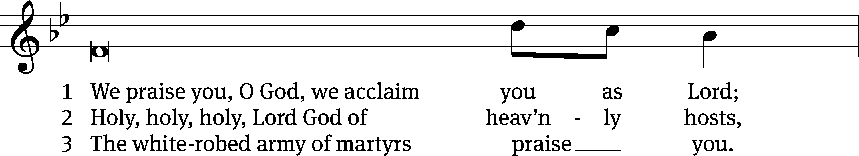
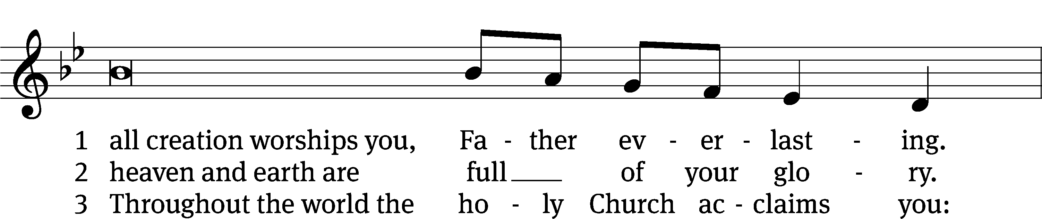
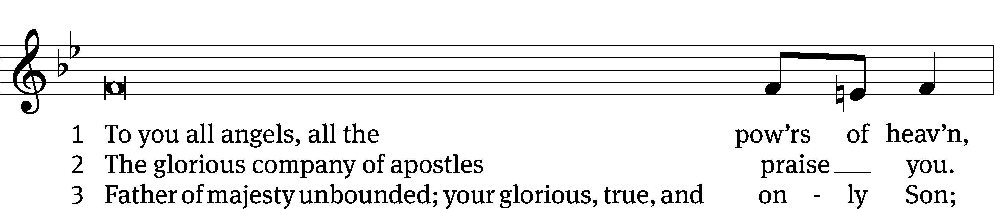
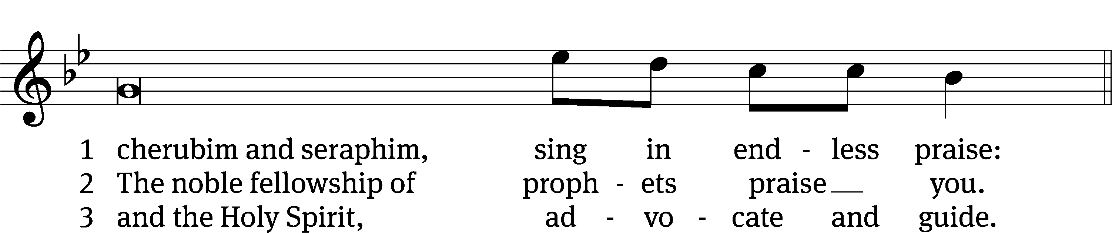

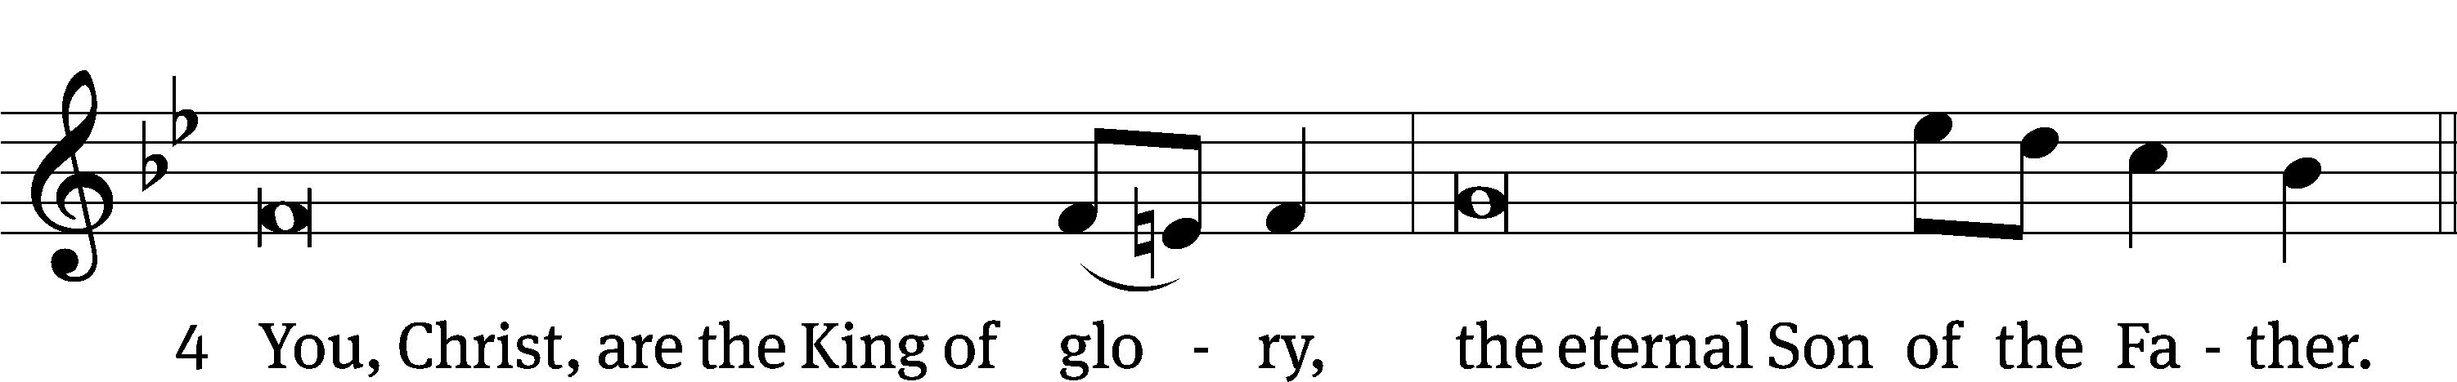
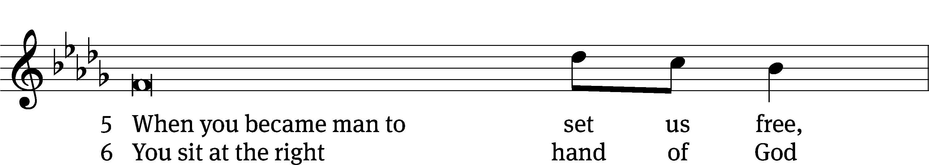
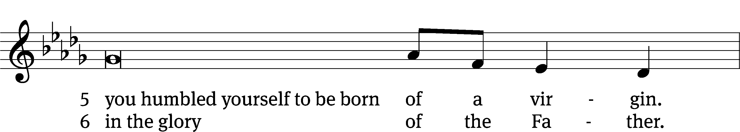
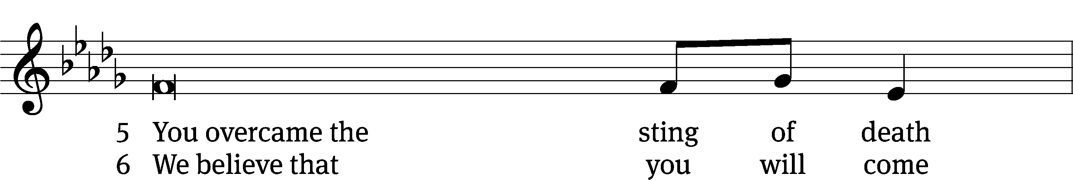
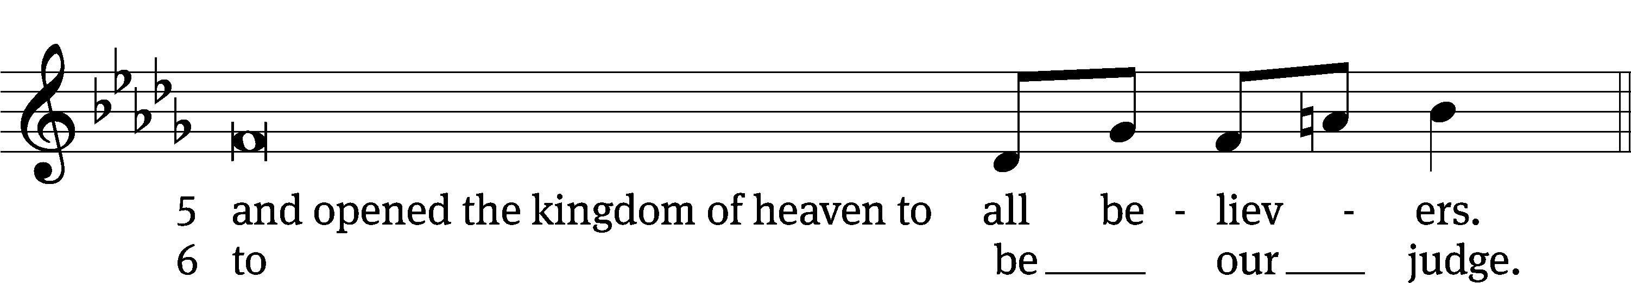
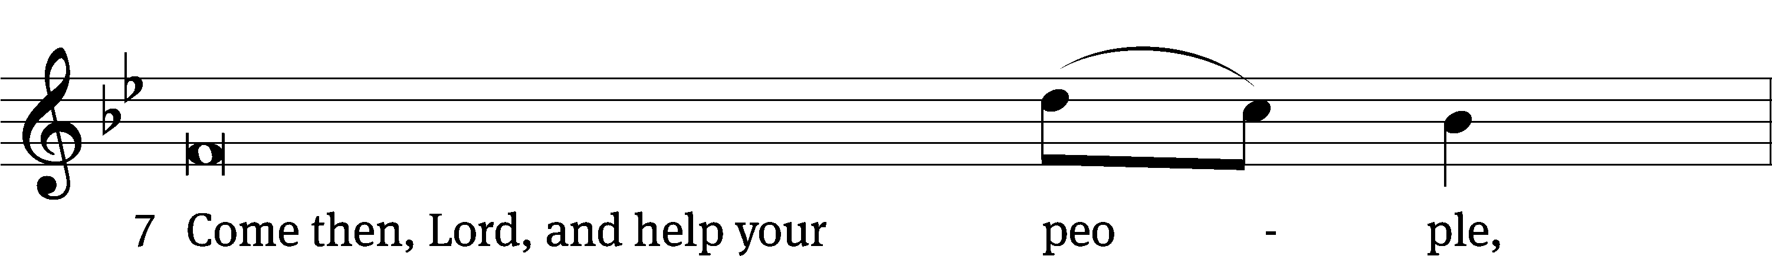
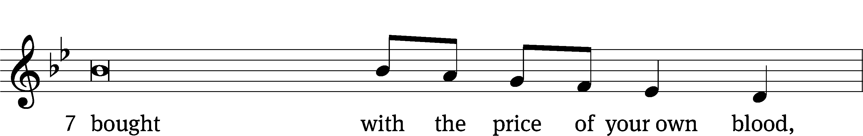
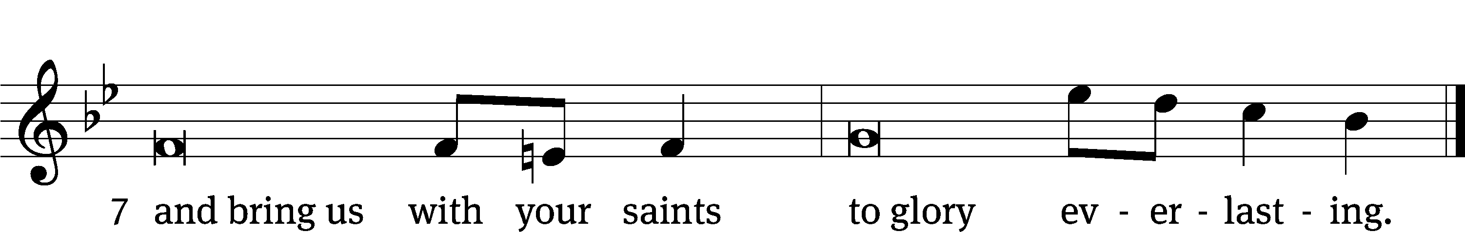

OFFERING
In response to God’s love and forgiveness, we give back a portion of what he has given us. The members of Christ Lutheran Church have joined to proclaim the gospel to this community. These offerings support that work. While our guests are welcome to participate, they should not feel obligated to do so.
PRAYER OF THE CHURCH
M: O Lord, in the midst of this life we are beset by many temptations. Fix our eyes on our Lord Jesus, who bore temptation for us and resisted to the point of death, and bring us through the evils of this fallen world to dwell with You forever. Lord, in Your mercy,
C: Hear our prayer.
M: Almighty God, You take no pleasure in the death of the wicked, but desire that they turn from evil and live. Give pastors courage to warn of sin and death. Give all Christians strength to defend that message. Turn sinners to life by the proclamation of Christ, who delivers from all unrighteousness. Lord, in Your mercy,
C: Hear our prayer.
M: Almighty God, preserve all catechumens and their teachers, all children and their parents, and every Christian home from the assaults of the evil one. As Your Son overcame Satan in the desert by the Word of God, so also give us the victory through Christ and His Word. Lord, in Your mercy,
C: Hear our prayer.
M: O Lord, You have established earthly authorities to punish evil and praise those who do good. Grant our rulers humble hearts to resist the allure of power and to worship You alone. Lord, in Your mercy,
C: Hear our prayer.
M: Merciful Father, though we deserve nothing of Your kindness, You have shown Yourself to be the strength of the weak, the healer of the sick and the hope of those who mourn. Hear us on behalf of those who are troubled in mind or body, the dying and those who grieve [especially _____________]. Sustain them through their afflictions and pain, heal them according to Your gracious will and deliver them at the last to everlasting life in Christ. Lord, in Your mercy,
C: Hear our prayer.

M: Merciful Father, though You gave us stewardship of Your good creation, we love the gifts more than the giver. Save us from trusting in our possessions more than in Your Son. Teach us to use what You have provided to help those in need and to relieve the poor, the unemployed and the oppressed. Lord, in Your mercy,
C: Hear our prayer.
M: Lord God, heavenly Father, You have given us a refuge from the world in the Body of Christ. Protect us from all evils of body and soul, that we would find rest in this life and eternal rest in Your heavenly embrace; through the same Jesus Christ, Your Son, our Lord, who lives and reigns with You and the Holy Spirit, one God, now and forever.
C: Amen.

LORD’S PRAYER Matthew 6:9-13; Luke 11:2-4
C: Our Father who art in heaven,
hallowed be thy name,
thy kingdom come,
thy will be done on earth as it is in heaven.
Give us this day our daily bread;
and forgive us our trespasses,
as we forgive those
who trespass against us;
and lead us not into temptation,
but deliver us from evil.
For thine is the kingdom, and the power,
and the glory
forever and ever. Amen.

THE BLESSING
M: The Lord bless you and keep you.
The Lord make his face shine on you and be gracious to you.
The Lord look on you with favor and ✙ give you peace.
C: Amen.
CLOSING HYMN The Tree of Life| CW 574

COPYRIGHT INFORMATION
Content requiring a copyright license is reproduced under OneLicense.net #A-718312. All rights reserved. The Common Service: Texts revised from The Lutheran Hymnal, 1941. Music revised by James Engel. Scripture Quotations: From the Holy Bible, New International Version (NIV 1984), © 1973, 1978, 1984 by Biblica, Inc.


13009 N. Elderberry Ct.
Lodi, CA 95242
www.christlodi.org
209-368-6250
Pastor Timothy Leistekow
WELCOME TO CHRIST EV. LUTHERAN CHURCH!
We preach a message of forgiveness, hope and peace
through the death and resurrection of Jesus Christ.
Families and individuals of all ages will find opportunities
both to grow and to serve.
Our mission statement:
Look what Christ is doing!
He binds us together in fellowship
He gathers us in for worship
He builds us up for service
He sends us out with the gospel

“Now you are the body of Christ,
and each one of you is a part of it.”
(1 Corinthians 12:27)

